Title of abstract (use 14 pt Times New Roman bold)

Firstname Lastname¹, Second Author^{1,2}, Third Author^{3*} (Use 11 pt Times New Roman)

¹ Affiliation of the first author, including address (Use 11 pt Times New Roman)
² University of Sopron, Faculty of Wood Engineering and Creative Industries. Bajcsy-Zs. Str. 4, Sopron, Hungary, 9400. In case of the same affiliation, you can group the authors.
³ Same for subsequent authors. The corresponding author should be marked with an asterisk (*).

E-mail: nemeth.robert@uni-sopron.hu; bak.miklos@uni-sopron.hu; bader.matyas@uni-sopron.hu (the e-mail addresses of all authors should be added as links in the order of authorship (Use 11 pt Times New Roman)

Keywords: keyword1; keyword2; keyword3. List 3 to 7 keywords of the subjects covered by the paper. (Use 11 pt Times New Roman)

abstract (Use 11 pt Times New Roman bold uppercase)
This document explains how to prepare an abstract for the „12th Hardwood Conference – Sopron. Please read the instructions carefully, they are formatted according to the guidelines and can be used as a template. If possible, please prepare your manuscript using ‘MS Word’ word processing software. Please upload the document during your registration (https://indico.uni-sopron.hu/e/12th-hardwood-conference-sopron-2026), or send it by email to hardwood-conference@uni-sopron.hu. The abstract should be between 150 and 1000 words. Submission of abstracts only supports the evaluation of applications (oral/poster/rejection). “Book of abstracts” will NOT be prepared. After acceptance, participants will be asked to submit a full paper for the Proceedings.

All abstracts should be written in English. Metric units (SI) should be used. It is assumed that the corresponding authors grant us copyright to use the abstracts during the evaluation process. Should the authors use tables or figures from other publications, it is assumed that permission has been obtained to do so. Only A4 portrait format accepted, all margins are 2.5 cm. Do not place any text outside of this area. Use Times New Roman 11 pt for the main text, without indentation and any spacing in the “Paragraph settings” of MS Word. Do not include headers and footers. Do not include page breaks and section breaks. Follow the formats given in this template. To emphasize a word or a phrase, use italics. Only use capitals or bold for the section headings as shown below.

To support the evaluation of your work by the Scientific Committee, tables and figures are also accepted in the abstract.

Tables
All tables and figures should be inserted into the text close to their first citation and must be numbered following their number of appearances. Tables should be included in the text but separated from the text by a blank line above and below (Times New Roman 11 pt). A caption with short and descriptive title should be given above the table in 11 pt Times New Roman italic, bold, centred.
In the table, use Times New Roman 10 pt. To facilitate the copy-editing of larger tables, smaller fonts may be used, but no less than 7 pt. Units should be given in square brackets. Place the tables embedded centred in the page. Tables should be editable, do not use images instead of tables. An example is given in Table 1.

Table 1: Results of the test
Specimen | Length [m] | Width [m] | Height [m] | Weight [kg]
1ª | 1 | 1 | 1 | 1
2 | 2 | 2 | 2 | 2
3^{b} | 3 | 3 | 3 | 3
4 | 4 | 4 | 4 | 4
ªBirch; ^{b}Poplar

Figures
Figures should be referred to in text as Figure 1, or as (Figure 1) and should be presented as part of the text, leaving a blank line above and below (Times New Roman 11 pt). Use Times New Roman 11 pt italic, bold, centred for the figure captions. The figure caption should be short and explanatory and should appear as a separate text below the image, not burned onto the image and not placed in a text box. Incorrectly edited images will be rejected.
Authors are encouraged to prepare figures and schemes in colour. A minimum image width of 5 cm with sufficiently high resolution is necessary (minimum 300 dpi). Each figure has to be an uneditable image: please avoid the use of image with separate text box, automatic shapes formed in the Word, editable graphs adopted from Excel, etc. If there is text in the figure, its size should match the figure caption for the final image size.

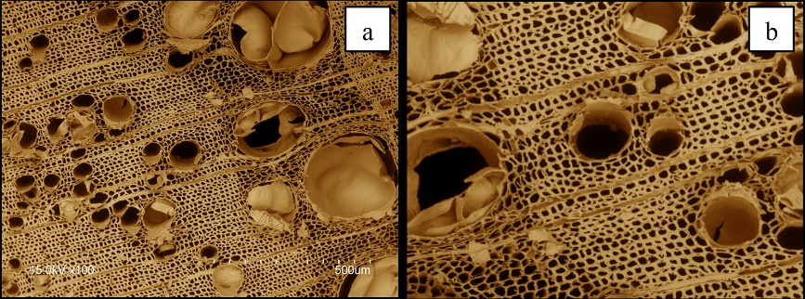
Figure 1: Coloured scanning electron micrograph of ash cross-section (a) and the centre of the same cross-section enlarged and rotated by 180° (b)

Text continues here as normal text. Acknowledgements, funding and references are not permitted in the abstract.

