Step 1. Please go to the following webpage to start registration process:
https://indico.uni-sopron.hu/
Step 2. Please select the conference by clicking on it:

Step 3. Please select the „Register now” option at the bottom of the page:
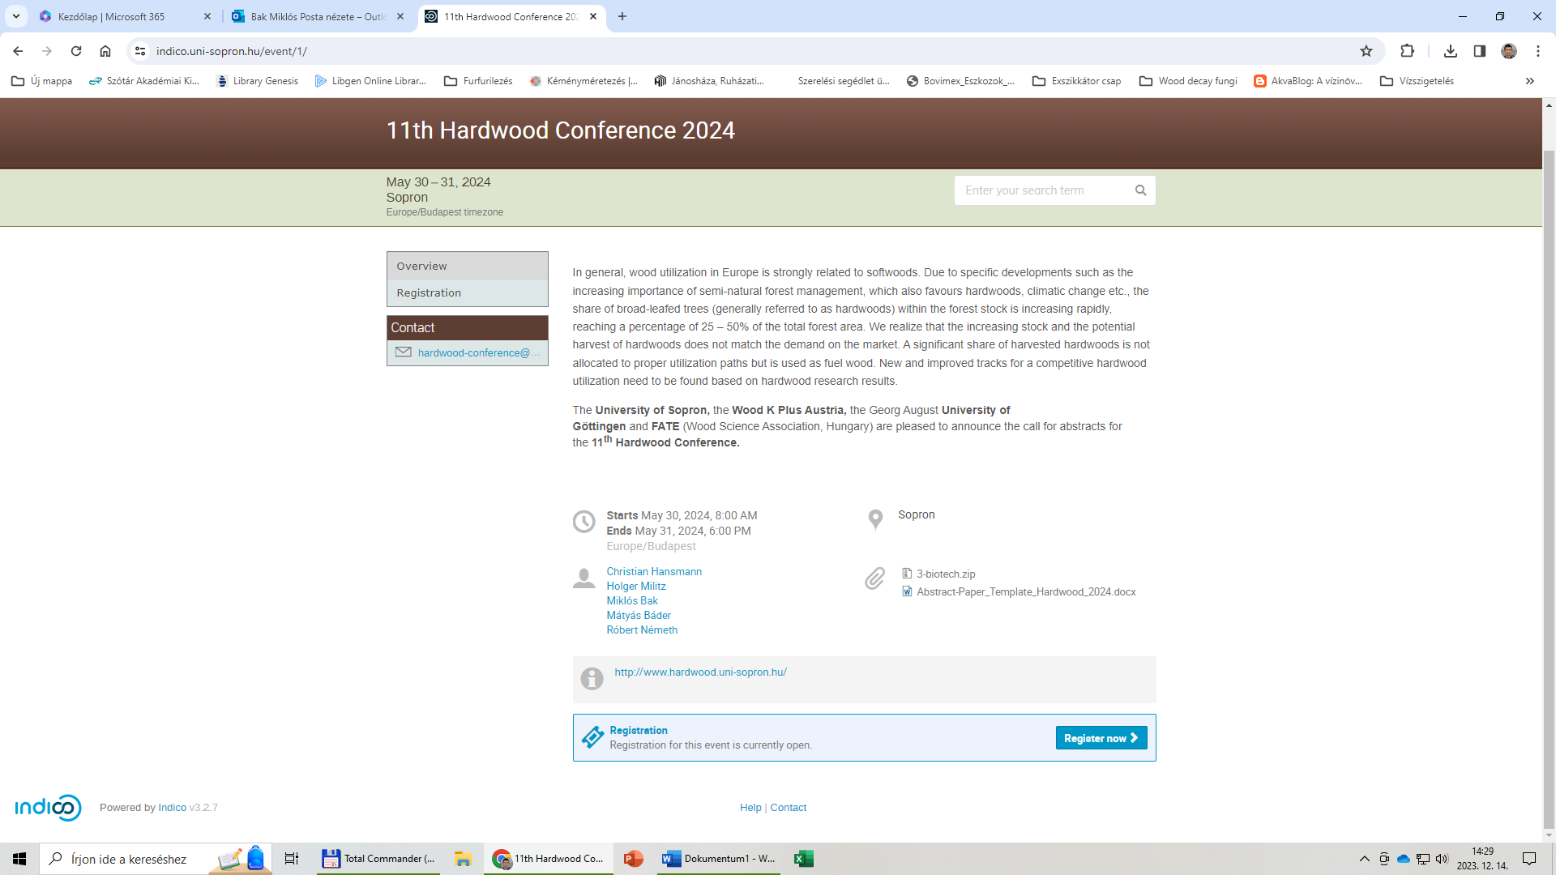

Step 4: Please select a registration option (Early bird / Full price / Student):
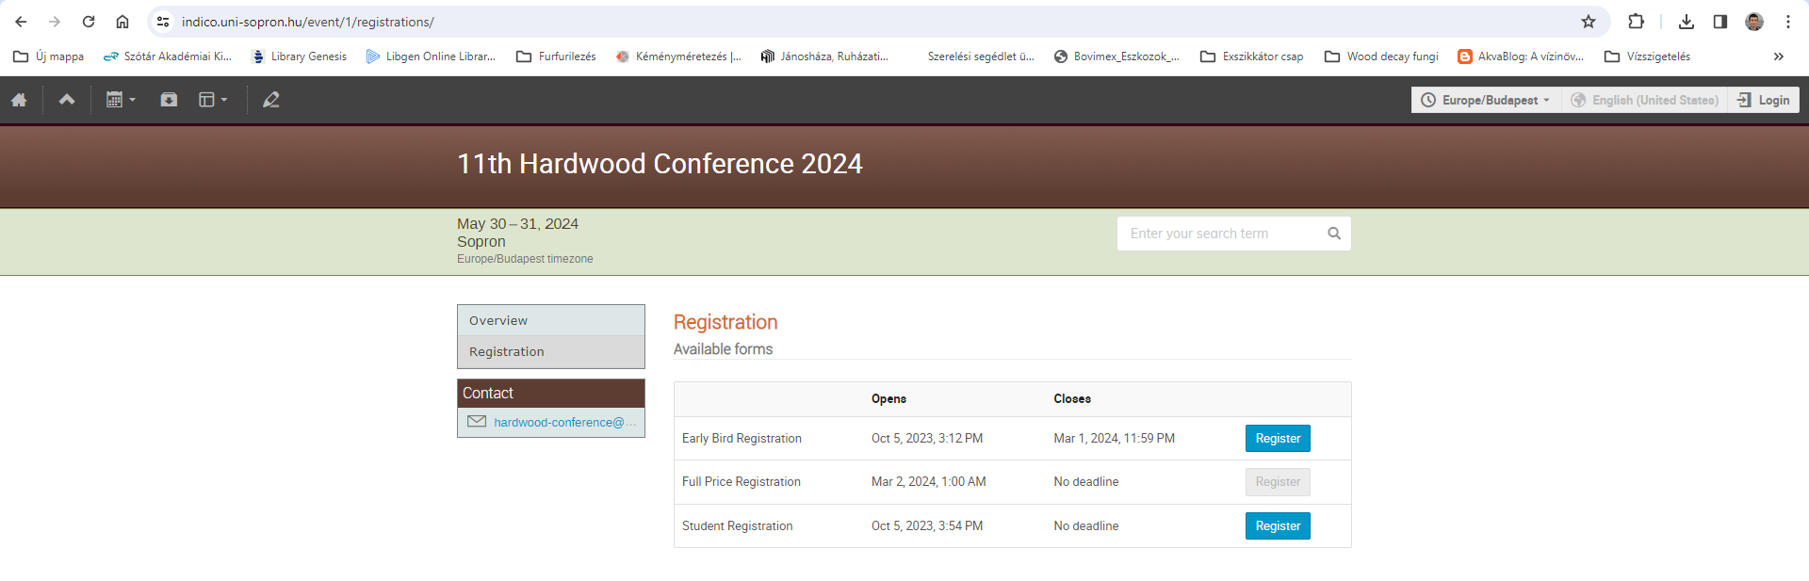
Step 5: Please select „Log in to proceed”:
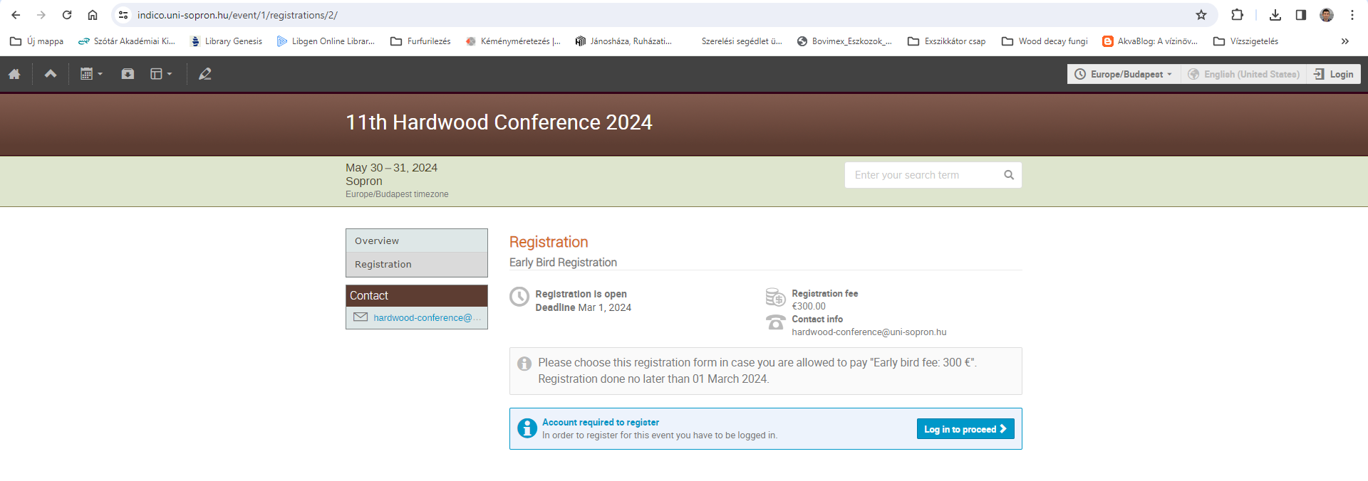

Step 6: To continue, you need to create a personal account in the Indico conference tool, as part of the registration procedure. Afterwards you can manage or modify your registration when logged in to your account.
Please click on „create one here”:
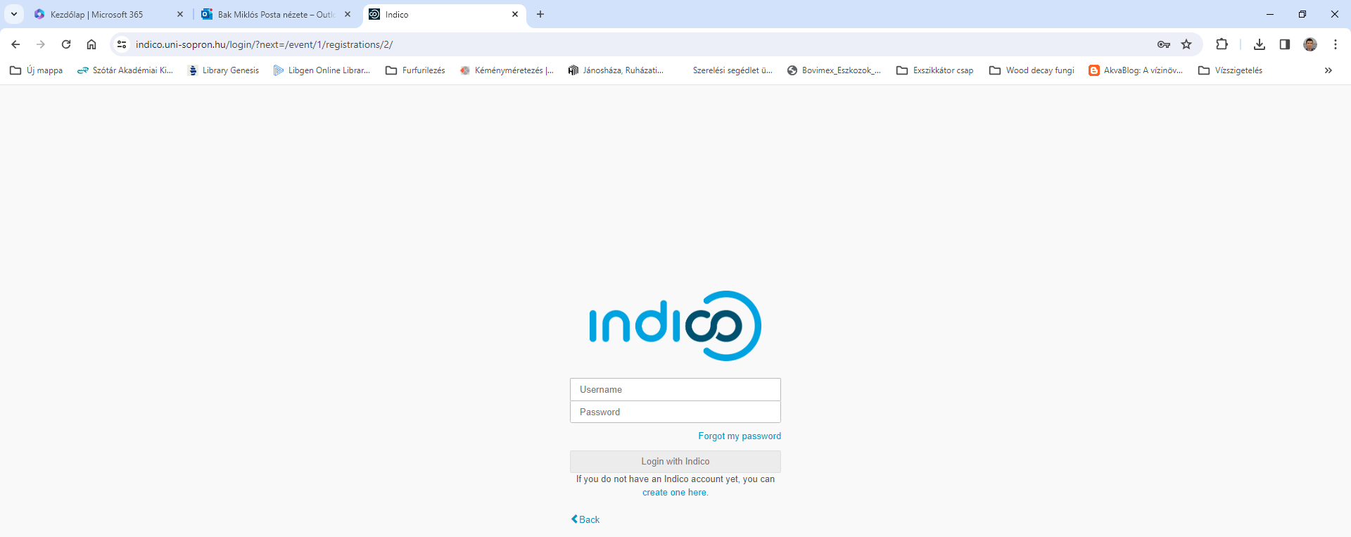

Step 7: Add your email address and complete CAPTCHA, than click „Send me a verification email”:
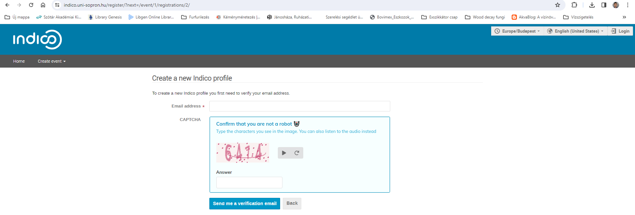

You shall get the following message:

Step 8: Open your mailbox and click on the link you received:

Step 9: Please fill in your data and add login details, then click „Create my Indico profile”:
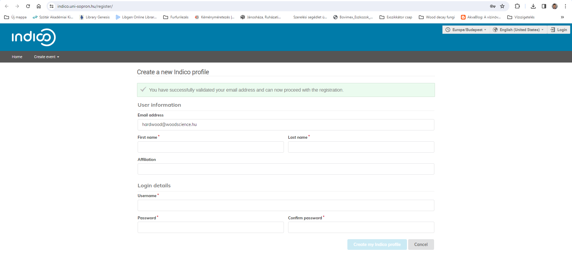

Step 10: Please fill the registration form:
