Title of paper (use 14 pt Times New Roman bold)

Firstname Lastname¹, Second Author^{1,2}, Third Author^{3*} (Use 11 pt Times New Roman)

¹ Affiliation of the first author, including address (Use 11 pt Times New Roman)
² University of Sopron, Institute of Wood Technology and Technical Sciences. Bajcsy-Zs. Str. 4, Sopron, Hungary, 9400. In case of the same affiliation, you can group the authors.
³ Same for subsequent authors. The corresponding author should be marked with an asterisk (*).

E-mail: nemeth.robert@uni-sopron.hu; bak.miklos@uni-sopron.hu; bader.matyas@uni-sopron.hu (the e-mail addresses of all authors should be added as links in the order of authorship (Use 11 pt Times New Roman)

Keywords: List 3 to 7 keywords of the subjects covered by the paper. (Use 11 pt Times New Roman)

abstract (Use 11 pt Times New Roman bold uppercase)
This document explains how to prepare an abstract and a camera-ready manuscript for the „11th Hardwood Conference – Sopron. Please read the instructions carefully, they are formatted according to the guidelines and can be used as a template. If possible, please prepare your manuscript using ‘MS Word’ word processing software. Please upload the document during your registration (https://indico.uni-sopron.hu/e/hardwoodconf2024), or send it by email to hardwood-conference@uni-sopron.hu. All margins are 2.5 cm. Do not place any text outside of this area. Use Times New Roman 11 pt for the main text. Do not include page numbers, they will be added later. Do not include headers and footers. Follow the formats given in this template. If the abstract or the manuscript does not meet the formal requirements included in this template, it will be returned only once for correction. The abstract should be between 100 and 500 words.

introduction
All manuscripts should be written in English. Metric units (SI) should be used. It is assumed that the corresponding authors grant us copyright to use the manuscript in the proceedings. Should the authors use tables or figures from other publications, it is assumed that permission has been obtained to do so. In the text, use Times New Roman 11 pt, without indentation and any spacing in the “Paragraph settings” of Word. To emphasize a word or a phrase, use italics. Only use capitals or bold for the section headings as shown below. Please note the following:
- Papers selected for oral presentation can be up to ten (10) pages long (including references, figures and tables).
- Papers selected for poster presentation can be up to five (5) pages long (including references, figures and tables).
Please do not exceed these page limits.

ORGANISATION OF THE TEXT
After the ABSTRACT and the INTRODUCTION, if appropriate to the content of the paper, please follow the next structure using the main section headings: MATERIALS AND METHODS, RESULTS AND DISCUSSION, CONCLUSIONS, (ACKNOWLEDGEMENTS) and REFERENCES. All text styles are set in this document; body text is 11-point Times New Roman. Main section headings are bold, left-justified and uppercase. Second level headings are left justified, bold, italics, lower case and underlined. Third level headings are left-justified, bold and lower case. The format of these and other parts can also be found in the Styles menu of the Word.

A Second Level Heading (use 11 pt Times New Roman bold underlined)
This is a second level heading.

A Third Level Heading (use 11 pt Times New Roman bold)
This is a third level heading. Use only when absolutely necessary.

Page Numbers
Do not include page numbers, they will be added later.

Tables
All tables and figures should be inserted into the main text close to their first citation and must be numbered following their number of appearance. Tables should be included in the text but separated from the text by a blank line above and below (Times New Roman 11 pt). A caption with short and descriptive title should be given above the table in 10 pt Times New Roman italic, bold, centred.
In the table, use Times New Roman 10 pt. To facilitate the copy-editing of larger tables, smaller fonts may be used, but no less than 7 pt. Units should be given in square brackets. Place the tables embedded centred in the page. Tables should be editable, do not use images instead of tables. An example is given below (Table 1).

Table 1: Results of the test
Specimen | Length [m] | Width [m] | Height [m] | Weight [kg]
1ª | 1 | 1 | 1 | 1
2 | 2 | 2 | 2 | 2
3^{b} | 3 | 3 | 3 | 3
4 | 4 | 4 | 4 | 4
ªBirch; ^{b}Poplar

Figures
Figures should be referred to in text as Figure 1, or as (Figure 1) and should be presented as part of the text, leaving a blank line above and below (Times New Roman 11 pt). Use Times New Roman 10 pt italic, bold, centred for the figure captions. The figure caption should be short and explanatory and should appear as a separate text below the image, not burned onto the image and not placed in a text box.
Authors are encouraged to prepare figures and schemes in colour. A minimum image width of 5 cm with sufficiently high resolution is necessary (minimum 300 dpi). Common formats are accepted, however, JPEG, PNG and EPS are preferred. All figures should be embedded in the text centred, using the “Top and Bottom” setting in the “Layout options”, or if not available, place it “In line with the text”. Each figure has to be an uneditable image: please avoid the use of image with separate text box, automatic shapes formed in the Word, editable graphs adopted from Excel, etc. If there is text in the figure, its size should match the figure caption for the final image size.

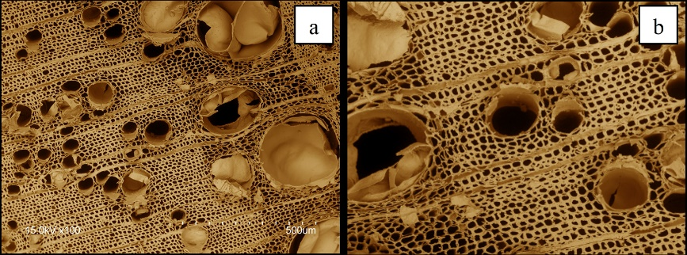

Figure 1: Coloured scanning electron micrograph of ash cross-section (a) and the centre of the same cross-section enlarged and rotated by 180° (b)

Equations
Equations should be referred to in the text as Eq. 1 (or Eq. 1). A blank line should be left above and below to separate the equation from the text (Cambria Math 11 pt). The equations should be numbered sequentially, with a number in brackets on the right side of the page. Only use the Word equation editor for equations. All equations must be editable, they cannot be accepted as images.

$a=\frac{b^{2}}{c_{3}}$ (1)

references
All references should contain enough information to allow a reader to find the cited materials. Use journal title abbreviations as described in the following site: https://images.webofknowledge.com/images/help/WOS/W_abrvjt.html
Cite references in the text using the author’s last name and date of publication as follows (Murphy 1990, Jones and Smith 1989, Davis et al. 1999). List the citations at the end of the manuscript in alphabetical order (examples given below). Please use the given formatting to ensure the Conference Proceedings a uniform appearance. Reference processing software as Zotero can help to easily adapt to the given style, using the following template: 3-biotech.csl. If you use a reference processing software, unlink the citations before submitting the manuscript. DOI references should be added where possible, as links (https://doi.org/10.35511/978-963-334-446-0).

Báder M, Németh R, Benke A, Köbölkuti ZA, Borovics A, Takács D (2022) Bending test results of plantation poplar clones. In: Németh R, Hansmann C, Rademacher P, Bak M, Báder M (eds) 10th Hardwood Conference Proceedings. University of Sopron Press, Sopron, Hungary, pp 75–82. https://doi.org/10.35511/978-963-334-446-0
Hisakata R, Nishida S, Johnston A (2016) An adaptable metric shapes perceptual space. Curr Biol 26:1911–1915. https://doi.org/10.1016/j.cub.2016.05.047
Hogue CWV (2001) Structure databases. In: Baxevanis AD, Ouellette BFF (eds) Bioinformatics, 2nd ed. Wiley-Interscience, New York, NY, USA, pp 83–109
ISO 13061-1 (2014) Physical and mechanical properties of wood - Test methods for small clear wood specimens - Part 1: Determination of moisture content for physical and mechanical tests. International Organization for Standardization, Geneva, Switzerland
Komán Sz (2012) Anatomical and physical characteristics of hybrid poplar species influencing the modern industrial and energy utilisation (Nemesnyár-fajták korszerű ipari és energetikai hasznosítását befolyásoló faanatómiai és fizikai jellemzők). PhD dissertation, Nyugat-Magyarországi Egyetem, Sopron, Hungary (in Hungarian)
Musk E (2006) The secret Tesla Motors master plan (just between you and me). In: Tesla Blog. https://www.tesla.com/blog/secret-tesla-motors-master-plan-just-between-you-and-me Accessed 29 Sep 2016
Sambrook J, Russell DW (2001) Molecular cloning: a laboratory manual, 3rd ed. CSHL Press, Cold Spring Harbor, NY, USA

