Title of paper (Use 12 pt Arial bold)

First Author1, Second Author2, Third Author3 (Use 12 pt Arial)

1 Address of first author, including country, affiliation, and email address (Use 10 pt Arial)

2 Same for second author

3 Same for subsequent authors

**Keywords:** List the keywords of the subjects covered by your paper (3 to 7). (Use Arial 10)

abstract

This document explains how to prepare a camera-ready manuscript for the *„11th Hardwood Conference – Sopron*. Please read the instructions carefully, they are formatted according to the guidelines and can be used as a template. If possible, please prepare your manuscript using ‘MS Word’ word processing software. Please submit the document using email to [hardwood@woodscience.hu](mailto:hardwood@woodscience.hu). All pictures, tables, and figures should be embedded in the text and centred. Top and bottom margins are 2.5 cm, right margin is 2 cm, and the left margin is 2.5 cm. Do not place any text outside of this area. *Do not include page numbers*, they will be added later. Do not include headers and footers.

Please note the following:

* Papers selected for oral presentation can be up to eight (8) pages long (including references).
* Papers selected for poster presentation can be up to four (4) pages long (including references).

Please do not exceed these page limits.

The abstract is optimally between 250 to 350 words long.

introduction

All manuscripts should be written in English. Metric units (SI) should be used. It is assumed that the corresponding authors grant us copyright to use the manuscript in the proceedings. Should the authors use tables or figures from other publications, it is assumed that permission has been obtained to do so. To emphasize a word or a phrase, use *italics*, only use capitals or bold for the section headings.

organisation of the text

Following the introduction, if appropriate to the content of the paper, please follow the following structure: EXPERIMENTAL METHODS, RESULTS AND DISCUSSION, CONCLUSIONS, REFERENCES. All text styles are set in this document, body text is 11-point Time New Roman. Main section headings are bold, centred, and capitalised. Second level headings are left justified, bold, italics, and lower case. Third level headings are left-justified, bold, lower case, underlined.

A Second Level Heading

This is a second level heading.

A third level heading

This is a third level heading.

Page numbers

Do not include page numbers, they will be added later.

Tables

These should be included in the text but separated from the text by a blank line above and below. A descriptive title should be given above the table in 10 pt. Times new Roman italic, bold centred. Units should be given in square brackets. An example is given below (Table 1).

***Table 1: Results of test***

|  |  |  |  |  |
| --- | --- | --- | --- | --- |
| **Specimen** | **Length [m]** | **Width [m]** | **Height [m]** | **Weight [kg]** |
| 1a | 1 | 1 | 1 | 1 |
| 2 | 2 | 2 | 2 | 2 |
| 3b | 3 | 3 | 3 | 3 |
| 4 | 4 | 4 | 4 | 4 |

*aBirch, bPoplar*

Figures

Figures should be referred to in text as Fig. 1, or as (Fig. 1) and should be presented as part of the text, again leaving a blank line above and below. Use Times New Roman 10 pt. bold for the figure captions. *If at all possible, all figures should be embedded in the text*.

Example:

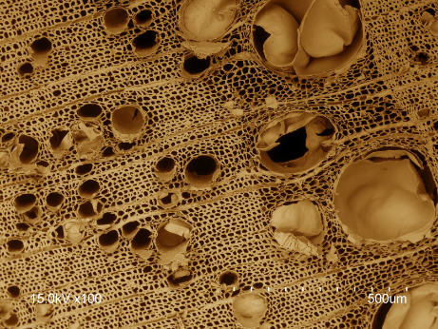

***Figure 1: Post-coloured scanning electron micrograph of ash cross-section***

Equations

Equations should be referred to in the text as Eq. 1 (or Eq. 1) and should be indented 0,5 cm. A line should be left above and below to separate the equation from the text. The equations should be numbered sequentially, with the number in brackets on the right hand side of the page.

*Example*:

a2 = b2 + c2 (1)

References

All references should contain enough information to allow a reader to find the cited materials. Do not abbreviate journal titles. Cite references in the text using the author’s last name and date of publication as follows (Murphy 1990, Jones and Smith 1989, Davis et al. 1999). List the citations at the end of the manuscript in alphabetical order (examples given below).

references

Ross, R.J., DeGroot, R.C. and Nelson W.J. (1994) Technique for the non-destructive evaluation of biologically degraded wood. *Experimental Techniques*, **18**(5), 29-32.

Clausen, C.A., Green III, F. and Highley, T.L. (1991) Early detection of brown-rot in southern yellow pine using monoclonal antibodies. In: *Proceedings of the 8th International Biodeterioration and Biodegradation Symposium*, ed. H.W. Rossmoore. Windsor, Ontario, pp. 412-414. Elsevier Applied Science, New York.

Jenkins, J.A. (1980a) *Fundamentals of Soil Mechanics*. Vol. I, John Wiley and Sons, New York.

Jenkins, J.A. (1980b) *Fundamental of Soil Mechanics*. Vol. II, John Wiley and Sons, New York.